**Spike:** Task 3

**Title:** GridWorld

**Author:** Sam Huffer, 101633177

**Goals / deliverables:**

* A simple plan of the code design
* Working code where:
  + The player can move their character through a grid-world of block positions, moving North, South, East and West.
  + If the player finds gold, they win. If they find a pit, they die.
  + If the player inputs Q, rather than N, S, E or W, they quit the game.
  + The game is case insensitive with regards to players’ input.

**Technologies, Tools, and Resources used:**

List of information needed by someone trying to reproduce this work

* Visual Studio 2017
* Inspiration 8 IE
* Draw.io

**Tasks undertaken:**

* Completed a quick plan of what variables and procedures would be necessary, as well as the logical flow of the game (see section “Plan”)
* Created an empty VS console application project to build this game in.

List key tasks likely to help another developer

This section should resemble a tutorial – the goal is to allow another coder to reproduce your work following these steps.

Eg: (Good)

* Download and install Visual Studio
* Download and install DirectX
* Configure VS Project File to point to the DX lib folder
* Compile sample code

Not: (Bad)

* Read the source code
* I had some trouble with SDL, so I spent a couple of weeks doing other spikes
* Run code
* Write Spike Report

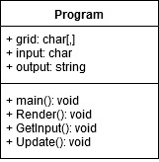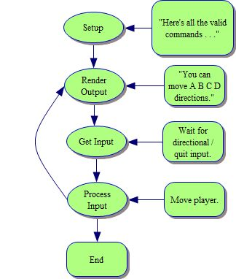**Plan:**

Figure 1: a basic outline of the variables and procedures to be implemented.

Figure 2: a basic outline of the logical flow of the GridWorld game.

**What we found out:**

Describe the outcomes, and how they relate to the spike topic + graphs/screenshots/outputs as needed

**Open issues/risks** [Optional – **remove** heading/section if not used!]**:**

List out the issues and risks that you have been unable to resolve at the end of the spike. You may have uncovered a whole range of new risks as well.

* eg. Risk xyz (new)

**Recommendations** [Optional – **remove** heading/section if not used!]**:**

Often based on any open issues/risks identified. You may state that another spike is required to resolve new issues identified (or) indicate that this spike has increased your confidence in XYZ and should move on.